**Bowel Prep Instructions – Extended Golytely®**

Your doctor will use a small camera to look inside your colon (bowel). In order to see inside, you will need to clean out your colon.

Please use this checklist to make sure you are ready for the procedure. If you do not, your procedure may be cancelled or have to be repeated. If you have questions, please contact your doctor's office.

**Date of my colonoscopy: *** Arrival time: \*\*\***

**Location of colonoscopy: Olathe Medical Center, Dr Building #2 Suite #101**

**20805 W 151st St, Olathe, Ks 66061**

**One week before my colonoscopy:**

**I need to buy:**

* Two 4-liter bottles of Golytely®/Nulytely® at the pharmacy. A prescription has been sent to my pharmacy. I may need to check with the pharmacy to see if they have Golytely®/Nulytely® in stock.

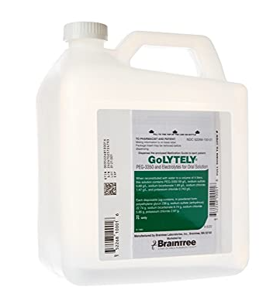

Dulcolax® (bisacodyl) laxative tablets (not a stool softener and not a suppository). You will only need 4 tablets for the prep.

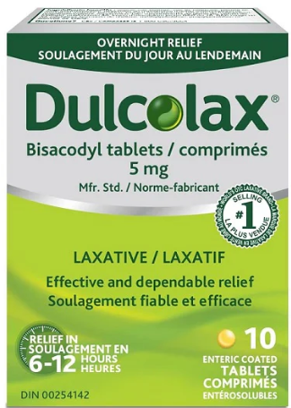

* Buy clear liquids. These are liquids that I can see through. Examples are water, clear broth, bouillon, clear sodas (7-Up®, Sprite®, ginger ale), apple juice, black coffee, tea, popsicles (no red or purple), Jell-O (no red or purple) and pulp free lemonade.
  + I will not be able to drink milk products, red- or purple-colored liquids, orange juice or alcohol.

□ **I need to tell my doctor about ALL the medicines I take.**

**Blood thinners** such as Coumadin® (warfarin), Plavix® (clopidogrel), Xarelto® (rivaroxaban), Eliquis® (apixaban), Pletal® (cilostazol), Brillinta® (ticagrelor), Aggrenox® (ASA/dipyridamole), Effient® (prasugrel) or Savaysa® (edoxaban).

* **Contact your prescribing physician *1 week prior* to your colonoscopy to ensure you can stop your medication.**

*\*\*Baby Aspirin (81mg) and full-strength Aspirin 325 mg is ok\*\**

**Diabetes medicines** may need to be adjusted. I will tell my primary care doctor that I am having a colonoscopy so they can change my doses, if needed.

**GLP-1 medications** such as Trulicity (dulaglutice), Bydureon, Ozempic (semaglutide), Wegovy (semaglutide), Mounjaro (terzepatide), Byetta (exenatide), Victoza (liraglutide), Saxenda (liraglutide), Adlyxin (lixisenatide), Rybelsus (semaglutide), Zepbound (tirzepatide). **If taking daily hold the day of procedure, if taken weekly hold 1 week prior to procedure.**

**Phentermine** will need to be held a minimum of **14 days** prior to the procedure.

**Blood pressure medicines** will continue as directed by my doctor. A nurse will tell me which medicines I can take on the day of the procedure.

**Vitamins and dietary supplements** will need to be stopped 5 days before my colonoscopy. This includes herbal supplements and fish oil.

□ **I need to arrange an adult to drive me to and from the procedure.**

I will be given medicines to make me sleepy and will not be able to drive or operate machines after the procedure. I will not be allowed to take a bus, taxi, Uber/Lyft, or walk home unless I am with an adult. My procedure will be cancelled if an adult is not with me.

**5 days before the procedure:**

* Stop taking iron pills, herbal medicines, supplements and vitamins.
* Stop eating nuts, seeds, popcorn and corn.

**2 days before the procedure:**

* At 9am, take 2 Dulcolax® tablets (5 mg each).
* I will drink only clear liquids after breakfast. I cannot eat any solid food or dairy products.
* In the morning, fill the first Golytely®/Nulytely® jug to the fill-line with water and shake well. Put in refrigerator for best taste.
* At 5pm, drink 8 oz. of Golytely®/Nulytely® every 15-30 minutes until you have only half of the jug left. Try to drink all of this in one hour. Stay near a bathroom. I can discard the remaining 2 liters from the jug.
* Most people will start to have diarrhea within 2 hours after drinking the mix. After some time, the diarrhea will be thin liquid with little or no solids.
* If I start to feel sick to my stomach, I will try drinking the mix slowly. Walking around may help.
* Continue to drink at least four 8 oz. glasses of clear liquids. No alcohol or marijuana.

**1 day before the procedure:**

* + - I will only drink clear liquids. I cannot eat any solid food or dairy products.
* In the morning, fill the second Golytely®/Nulytely® jug to the fill-line with water and shake well. Put in refrigerator for best taste.
  + - At noon take 2 Dulcolax® tablets. Drink at least four 8 oz. glasses of clear liquids
    - At 5pm, drink 8 oz. of Golytely®/Nulytely® every 15-30 minutes until you have only half of the jug left. Stay near a bathroom.
* If I start to feel sick to my stomach, I will try drinking the mix slowly. Walking around may help.
* Continue to drink at least four 8 oz. glasses of clear liquids. No alcohol or marijuana. **If I chew tobacco, I will stop using 8 hours before my procedure.**

**Morning of the procedure:**

* + - 5 hours prior to your procedure drink 8 oz. of Golytely®/Nulytely® every 15-30 minutes until you have no more left in the jug. Stay near a bathroom.
* The last bowel movement before my arrival should be like water.
  + **No fluids, including water, 2 hours prior to the procedure**.

If you have any questions, please call our office at 913-355-3896.